Kubernetes Task-08
- Create and Test a Kubernetes Pod with an EmptyDir Volume
  - Create YAML file
vi emptydir-pod.yaml
apiVersion: v1
kind: Pod
metadata:
name: emptydir-demo
spec:
containers:
- name: writer
image: busybox
command: ["sh", "-c", "while true; do echo 'Hello EmptyDir' > /data/message.txt; sleep 30; done"]
volumeMounts:
- name: shared-volume
mountPath: /data
- name: reader
image: busybox
command: ["sh", "-c", "while true; do cat /data/message.txt; sleep 30; done"]
volumeMounts:
- name: shared-volume
mountPath: /data
volumes:
- name: shared-volume
emptyDir: {}
  - Apply file
kubectl apply -f emptydir-pod.yaml
  - Check pod
kubectl get pods
Expected:
emptydir-demo 2/2 Running
  - Verify file from reader container
kubectl exec -it emptydir-demo -c reader -- cat /data/message.txt
Expected output:
Hello
  - Test by creating another file
kubectl exec -it emptydir-demo -c writer -- sh
Inside container:
echo "EmptyDir volume is working" > /data/test.txt
exit
Now check from reader:
kubectl exec -it emptydir-demo -c reader -- cat /data/test.txt
Expected:
EmptyDir volume is working
  - Delete pod after test
kubectl delete pod emptydir-demo
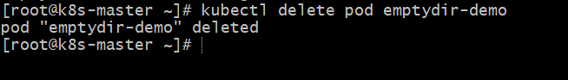
- Configure a HostPath Volume in Kubernetes and Validate Data Persistence
  - Create this file:
vi hostpath-pod.yaml
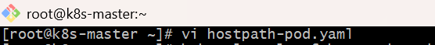
apiVersion: v1
kind: Pod
metadata:
name: hostpath-demo
spec:
containers:
- name: nginx
image: nginx
volumeMounts:
- name: host-volume
mountPath: /data
volumes:
- name: host-volume
hostPath:
path: /tmp/hostpath-data
type: DirectoryOrCreate
  - Apply:
kubectl apply -f hostpath-pod.yaml
kubectl get pod hostpath-demo -o wide
  - Create data inside pod:
kubectl exec -it hostpath-demo -- sh
echo "Hello from HostPath volume" > /data/test.txt
cat /data/test.txt
exit
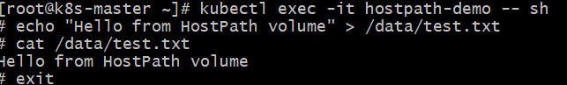
  - Now check on the node where pod is running:
kubectl get pod hostpath-demo -o wide
SSH/login to that node, then run:
cat /tmp/hostpath-data/test.txt
You should see:
Hello from HostPath volume
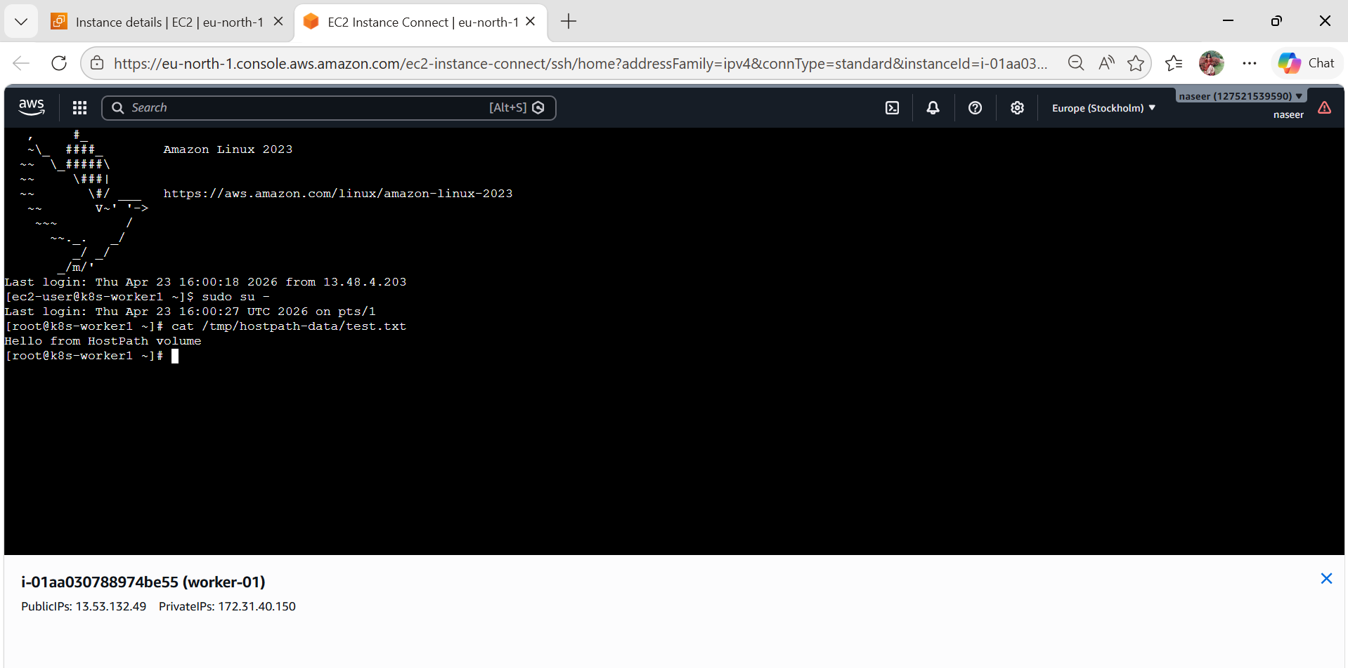
  - Now delete pod:
kubectl delete pod hostpath-demo
  - Recreate it:
kubectl apply -f hostpath-pod.yaml
kubectl exec -it hostpath-demo -- cat /data/test.txt
If pod comes on the same node, data will still be there:
Hello from HostPath volume
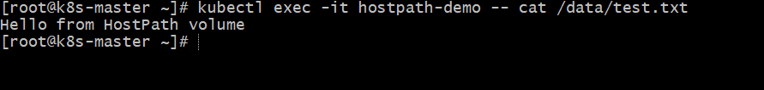

- Deploy an Amazon EBS Volume Using Persistent Volume and Persistent Volume Claim (PVC)
  - Create EBS volume
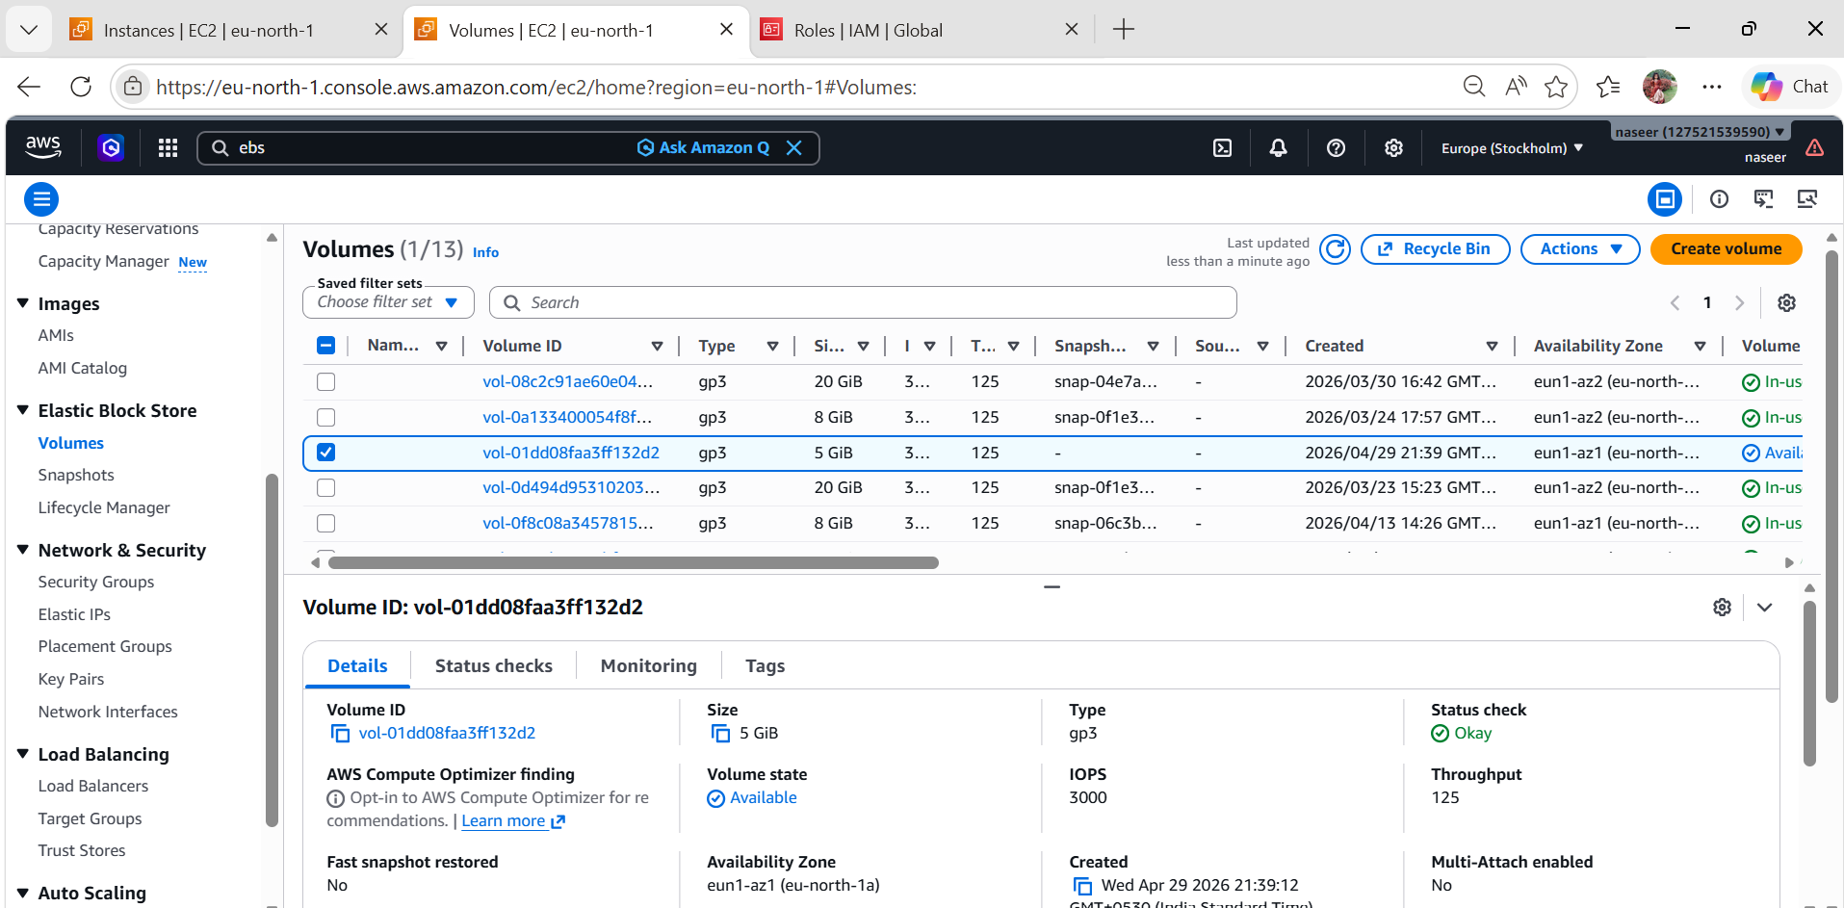
  - Create IAM role
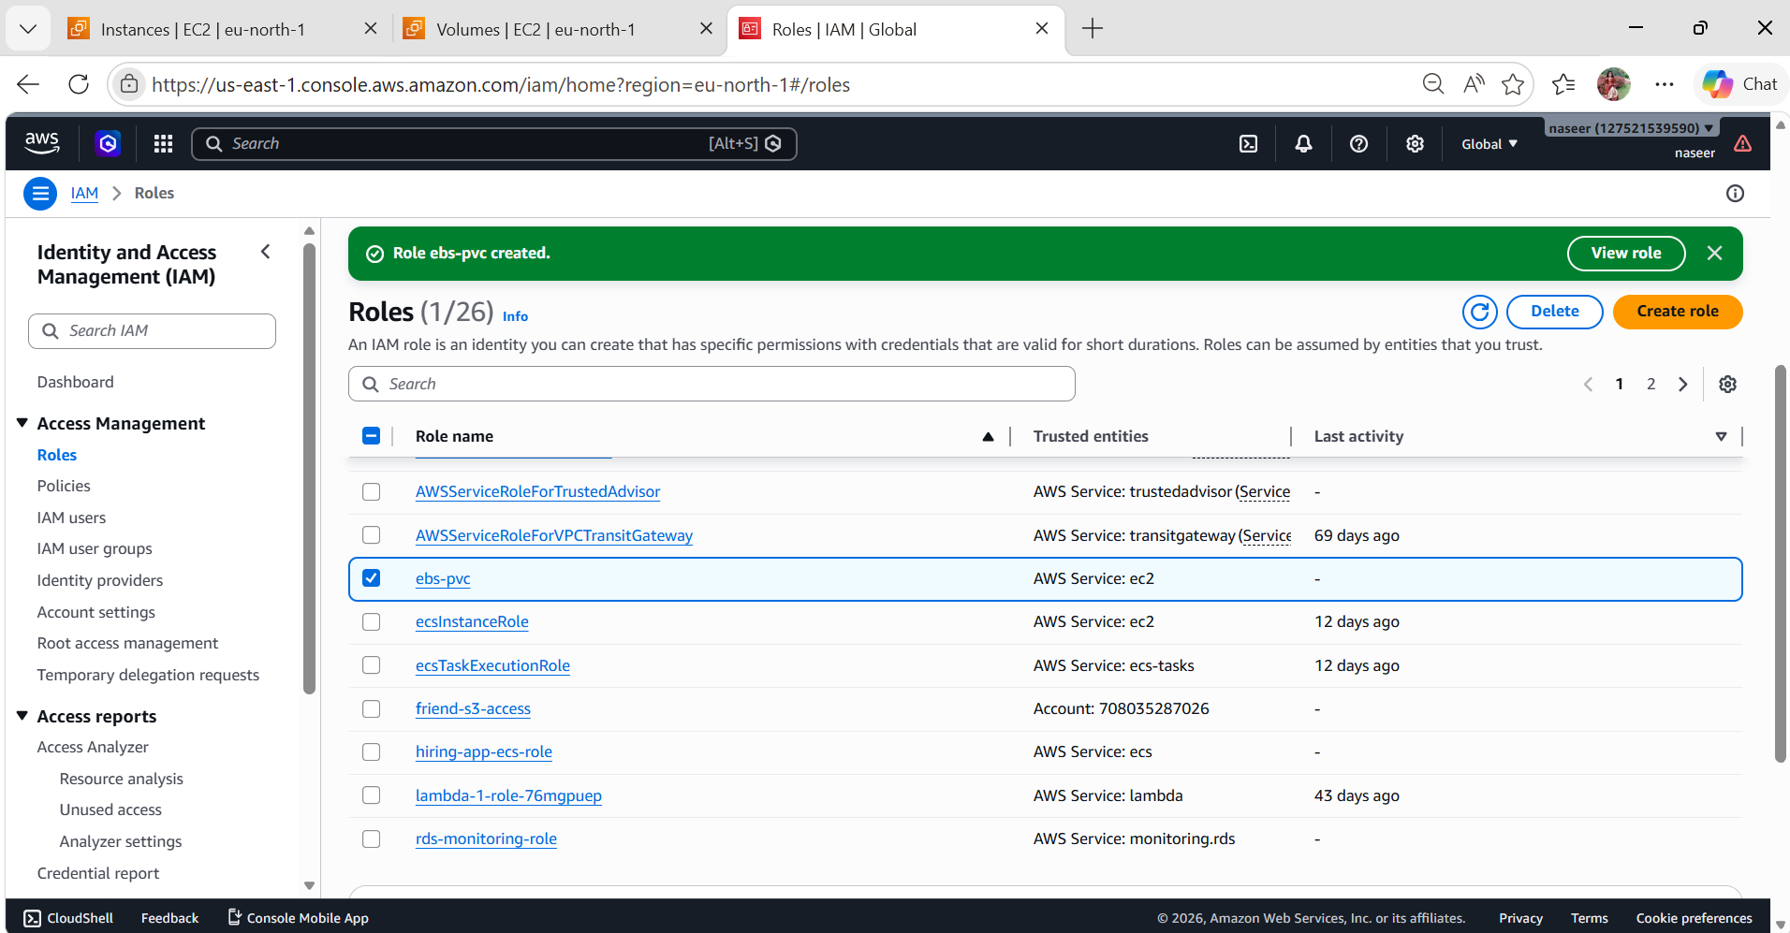

  - For All 3 Nodes modify IAM role
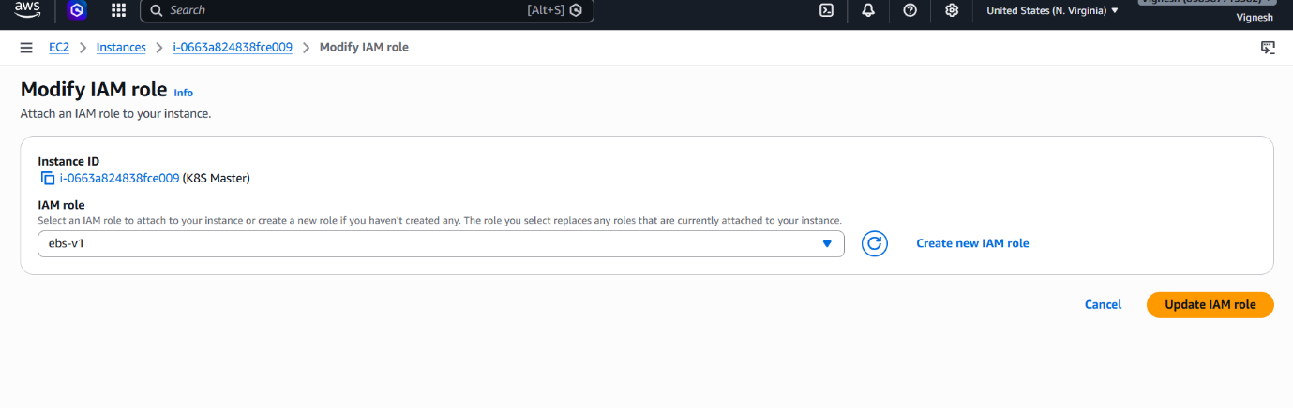
  - Install git
sudo yum install git -y
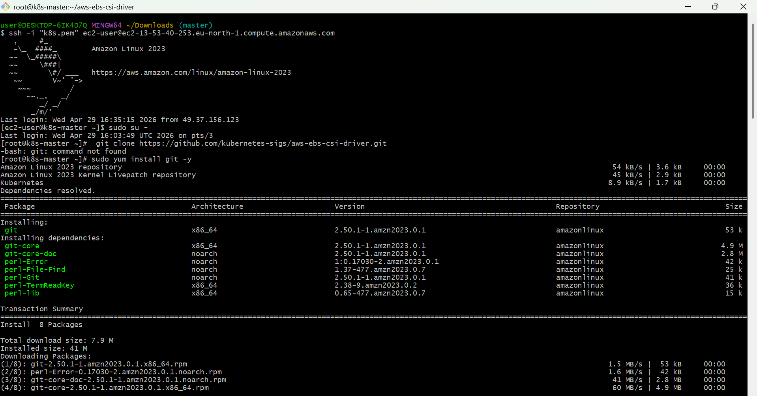
  - Install AWS EBS CSI driver on k8s master node.
git clone https://github.com/kubernetes-sigs/aws-ebs-csi-driver.git
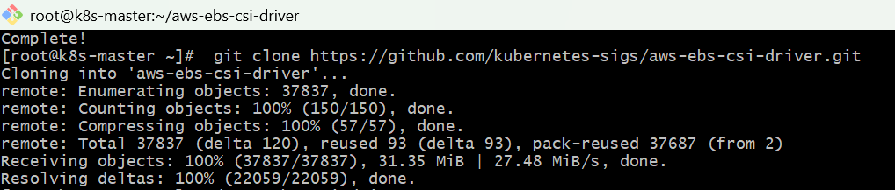
cd aws-ebs-csi-driver
kubectl apply -k deploy/kubernetes/overlays/stable/
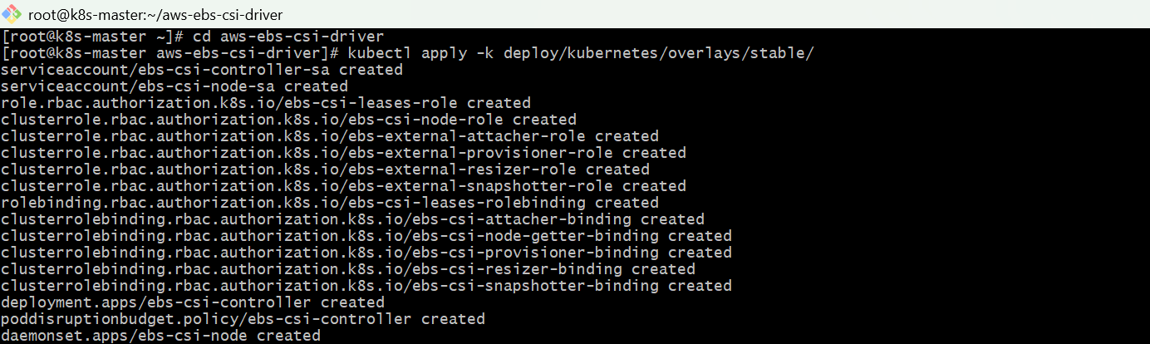
kubectl get pods -n kube-system
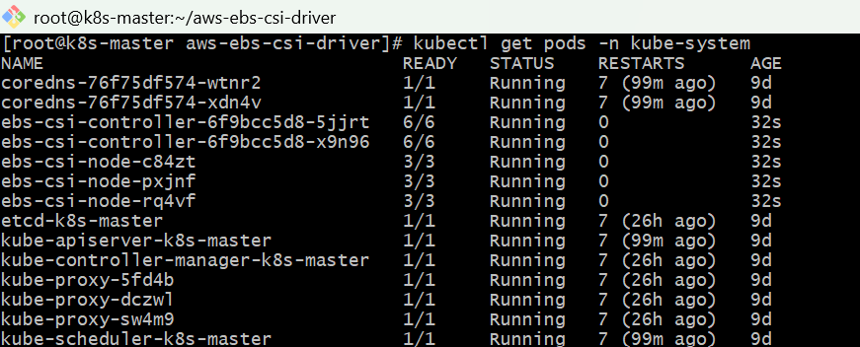
  - Create vi pv.yaml file
apiVersion: v1
kind: PersistentVolume
metadata:
name: my-ebs-pv
spec:
capacity:
storage: 10Gi
accessModes:
- ReadWriteOnce
persistentVolumeReclaimPolicy: Retain
storageClassName: aws-ebs
awsElasticBlockStore:
volumeID: <your-ebs-volume-id> #EBS volume ID
fsType: ext4
  - apply:
kubectl apply -f pv.yaml
kubectl get pv
  - Create vi ebs-pvc.yaml
apiVersion: v1
kind: PersistentVolumeClaim
metadata:
name: ebs-pvc
spec:
accessModes:
- ReadWriteOnce
resources:
requests:
storage: 5Gi
  - Apply:
Kubectl apply -f ebs-pvc.yaml
Kubectl get pvc
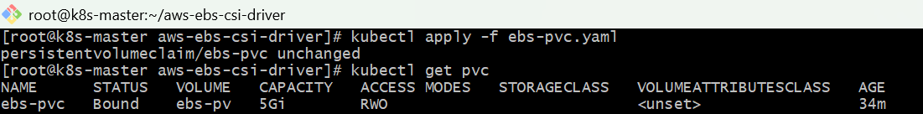
  - Create vi ebs-pod.yaml
apiVersion: v1
kind: Pod
metadata:
name: ebs-demo-pod
spec:
containers:
- name: nginx
image: nginx
volumeMounts:
- name: ebs-storage
mountPath: /usr/share/nginx/html
volumes:
- name: ebs-storage
persistentVolumeClaim:
claimName: ebs-pvc
  - apply:
kubectl apply -f ebs-pod.yaml
kubectl get pods
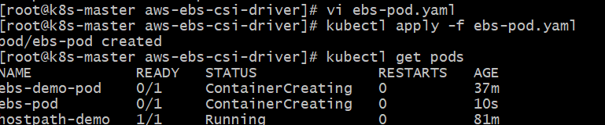
  - Test Storage
Enter Pod:
kubectl exec -it ebs-pod – sh
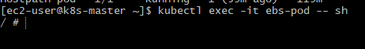
Inside:
echo "EBS storage working" > /data/test.txt
cat /data/test.txt
exit
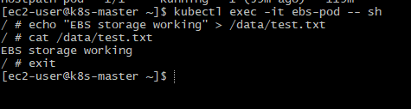
  - Test Persistence
Delete Pod:
kubectl delete pod ebs-pod
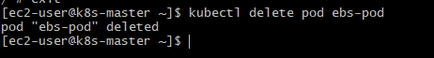

  - Recreate:
kubectl apply -f ebs-pod.yaml
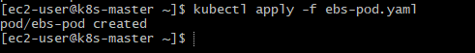
  - Check again:
kubectl exec ebs-pod -- cat /data/test.txt
👉 Output:
EBS storage working
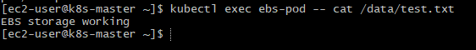

- Set Up an Amazon EFS Volume and Attach it to Multiple Pods
  - Login to aws and create on efs volume.
  - Create one access point to your efs volume.
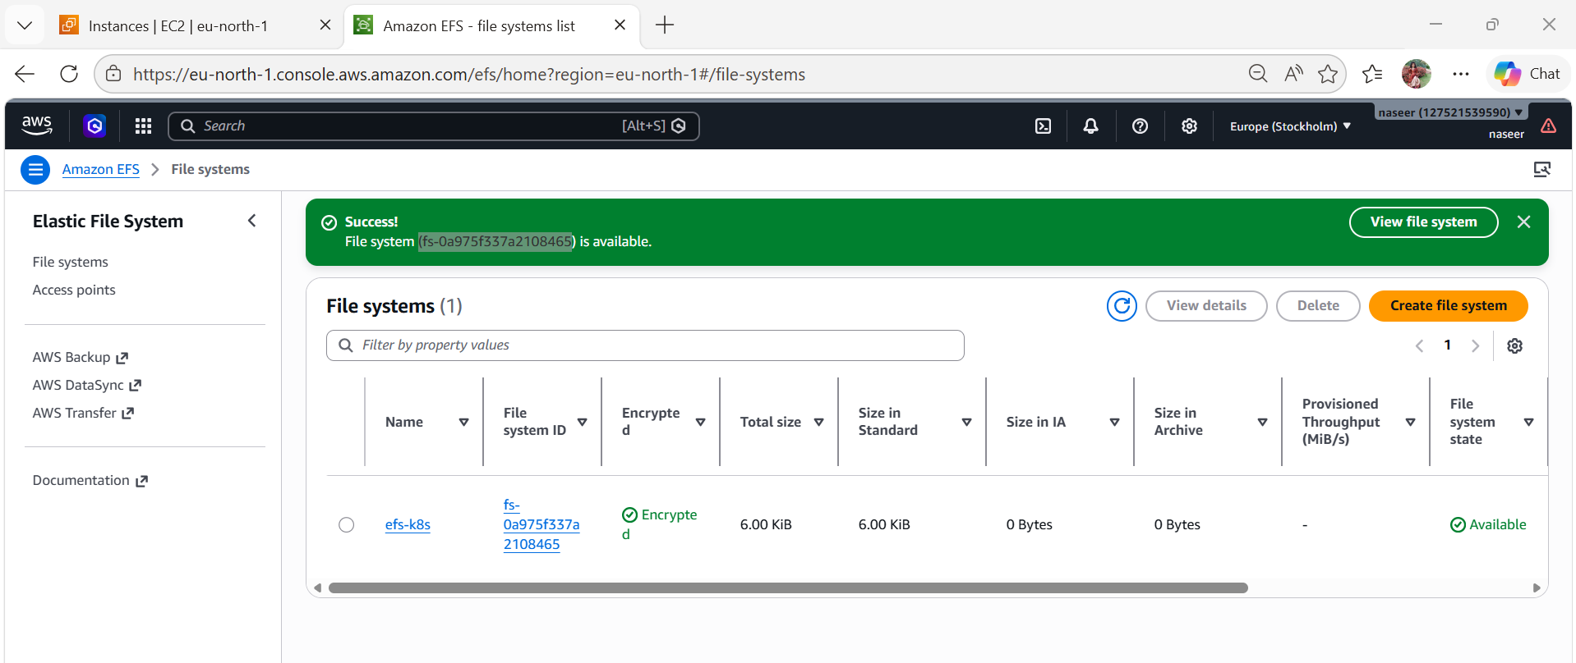
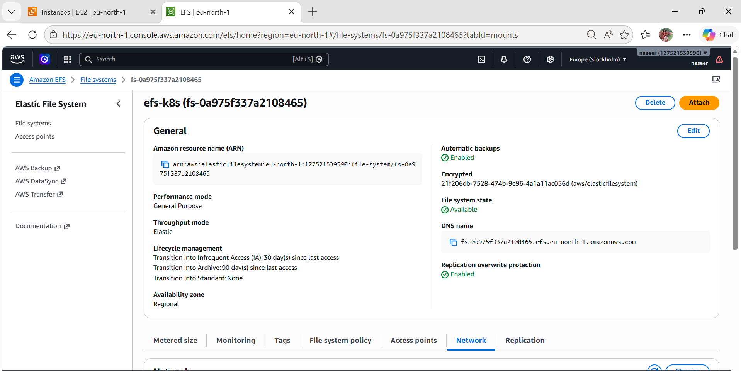
  - Install AWS EFS CSI driver on k8s master node.
# git clone https://github.com/kubernetes-sigs/aws-efs-csi-driver.git
Apply the CSI Driver Manifests: Navigate to the cloned repository and apply the
Kubernetes manifests using the kubectl apply command:
# cd aws-efs-csi-driver/deploy/kubernetes/overlays/stable/
# kubectl apply -k .
verify the installation.
#kubectl get pods -n kube-system -l app=efs-csi-controller
#kubectl get pods -n kube-system -l app=efs-csi-node

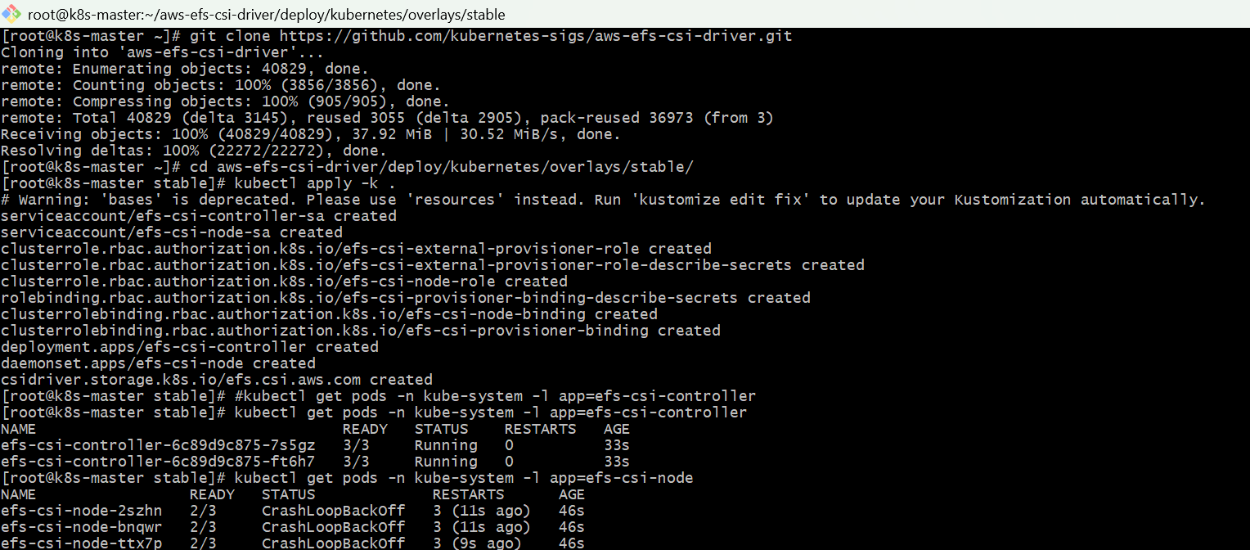
  - Create PV and PVC
Create file:
vi efs-pv.yaml
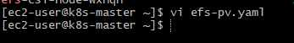
Paste this. Replace fs-xxxxxxxx with your EFS ID.
apiVersion: v1
kind: PersistentVolume
metadata:
name: efs-pv
spec:
capacity:
storage: 5Gi
volumeMode: Filesystem
accessModes:
- ReadWriteMany
persistentVolumeReclaimPolicy: Retain
storageClassName: efs-sc
csi:
driver: efs.csi.aws.com
volumeHandle: fs-xxxxxxxx
---
  - Apply:
kubectl apply -f efs-pv.yaml
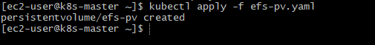
  - Create PVC
vi efs-pvc.yaml
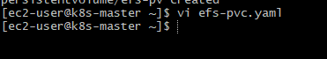
apiVersion: v1
kind: PersistentVolumeClaim
metadata:
name: efs-pvc
spec:
accessModes:
- ReadWriteMany
storageClassName: efs-sc
resources:
requests:
storage: 5Gi
Apply:
kubectl apply -f efs-pv-pvc.yaml
Check:
kubectl get pv
kubectl get pvc
PVC should show:
STATUS: Bound
  - Apply:
kubectl apply -f efs-pvc.yaml
kubectl get pvc
Should be:
Bound

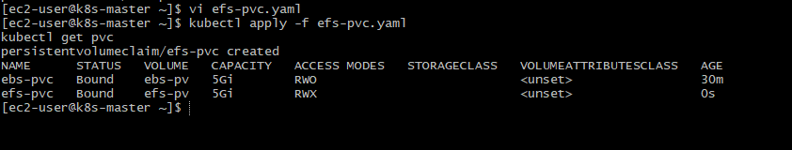
  - Create TWO Pods using same PVC
Pod 1
Create file:
vi efs-pod1.yaml
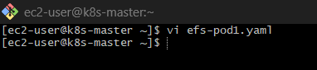
Paste:
apiVersion: v1
kind: Pod
metadata:
name: efs-pod-1
spec:
containers:
- name: app
image: busybox
command: ["/bin/sh", "-c", "sleep 3600"]
volumeMounts:
- mountPath: /data
name: efs-volume
volumes:
- name: efs-volume
persistentVolumeClaim:
claimName: efs-pvc
Pod 2
Create file:
  - vi efs-pod2.yaml
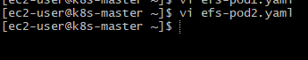
Paste
apiVersion: v1
kind: Pod
metadata:
name: efs-pod-2
spec:
containers:
- name: app
image: busybox
command: ["/bin/sh", "-c", "sleep 3600"]
volumeMounts:
- mountPath: /data
name: efs-volume
volumes:
- name: efs-volume
persistentVolumeClaim:
claimName: efs-pvc
  - Apply both:
kubectl apply -f efs-pod1.yaml
kubectl apply -f efs-pod2.yaml
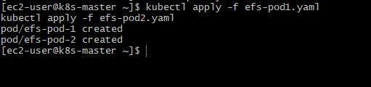
  - Test shared storage
Write from Pod 1
kubectl exec -it efs-pod-1 – sh
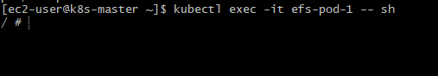
echo "Hello from Pod1" > /data/shared.txt
exit
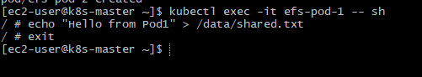
Read from Pod 2
kubectl exec -it efs-pod-2 -- cat /data/shared.txt
Output:
Hello from Pod1
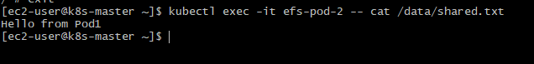

- Implement and Test Liveness and Readiness Probes in a Kubernetes Pod
Task: Implement and Test Liveness and Readiness Probes
  - Create YAML file
vi probe-pod.yaml
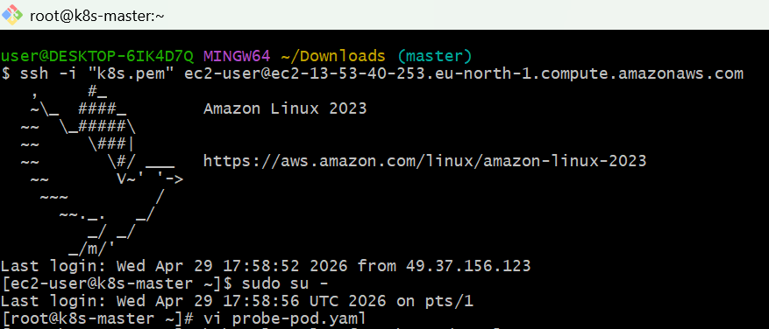
Paste this:
apiVersion: v1
kind: Pod
metadata:
name: probe-demo
labels:
app: probe-demo
spec:
containers:
- name: nginx
image: nginx
ports:
- containerPort: 80
readinessProbe:
httpGet:
path: /
port: 80
initialDelaySeconds: 5
periodSeconds: 5
livenessProbe:
httpGet:
path: /
port: 80
initialDelaySeconds: 10
periodSeconds: 10
  - Apply YAML
kubectl apply -f probe-pod.yaml
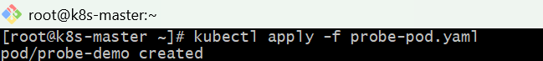
  - Check pod status
kubectl get pod probe-demo
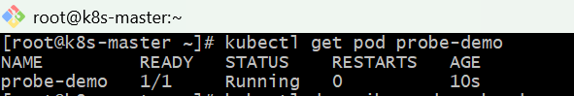
kubectl describe pod probe-demo
You should see readiness and liveness probe events.
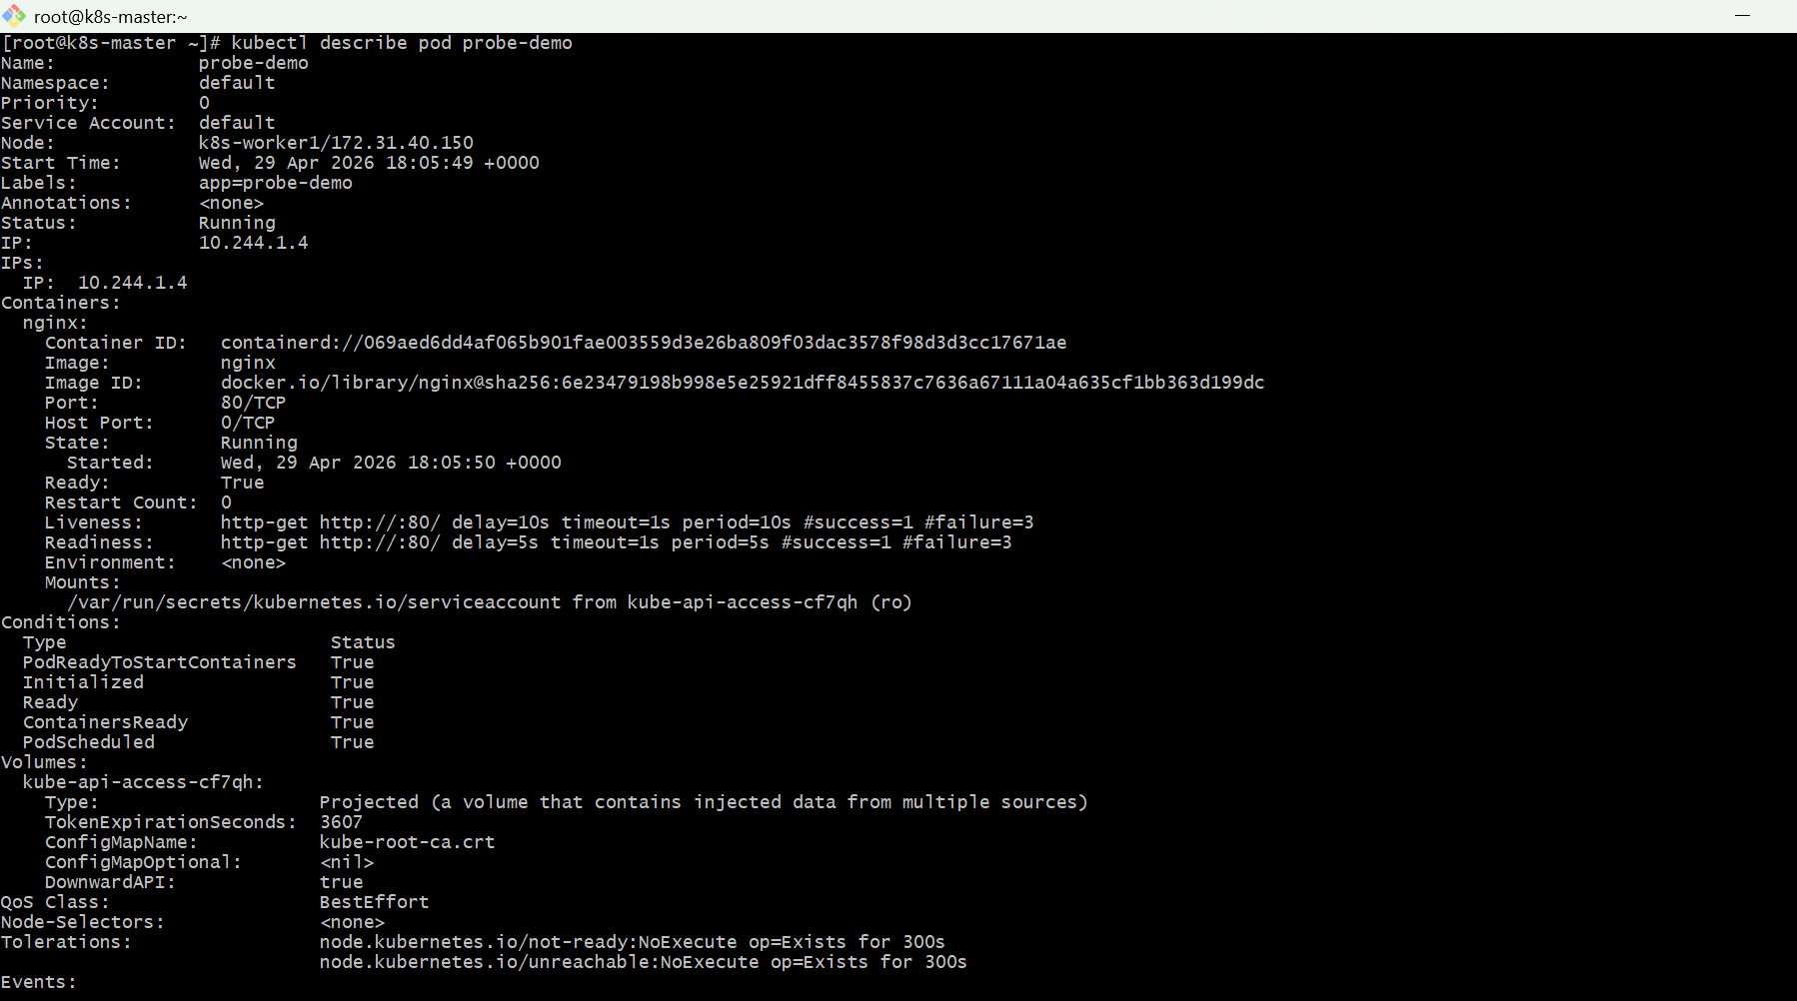
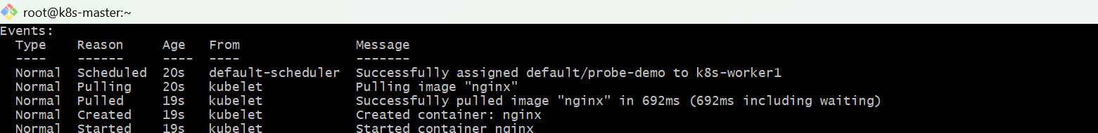
  - Test readiness
Break nginx index page:
kubectl exec -it probe-demo -- mv /usr/share/nginx/html/index.html /usr/share/nginx/html/index.html.bak
Check:
kubectl get pod probe-demo
kubectl describe pod probe-demo
Pod may show 0/1 READY.
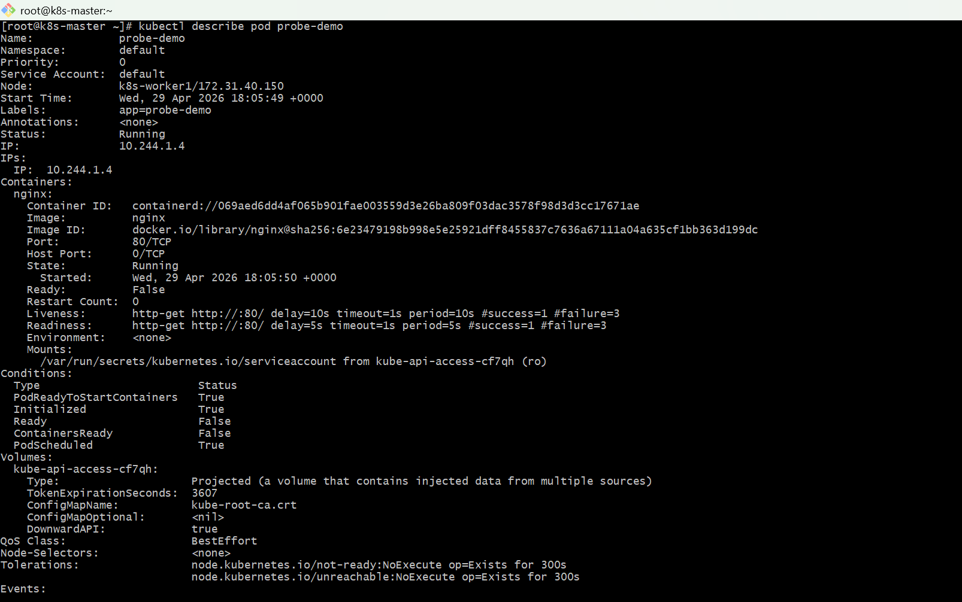
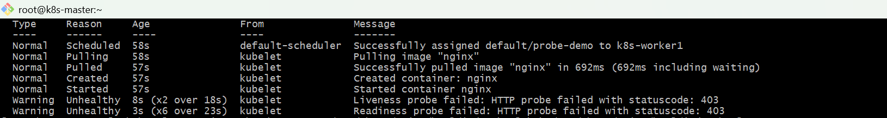
  - Restore readiness
kubectl exec -it probe-demo -- mv /usr/share/nginx/html/index.html.bak /usr/share/nginx/html/index.html
kubectl get pod probe-demo
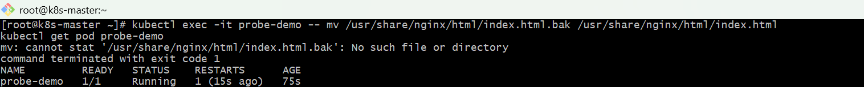
  - Test liveness
Stop nginx inside container:
kubectl exec -it probe-demo -- nginx -s stop
  - Wait and check:
kubectl get pod probe-demo
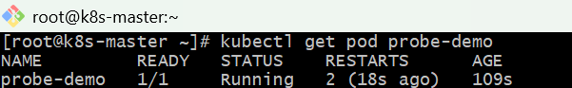
kubectl describe pod probe-demo
You should see restart count increase.
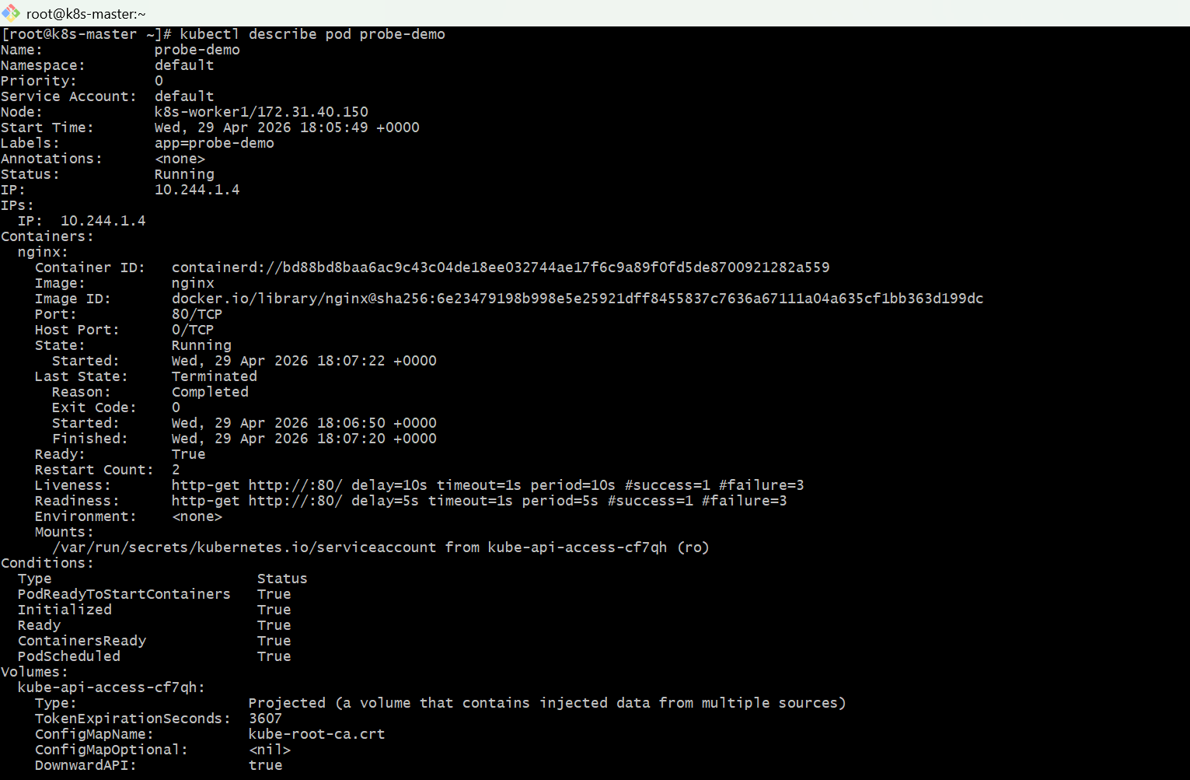
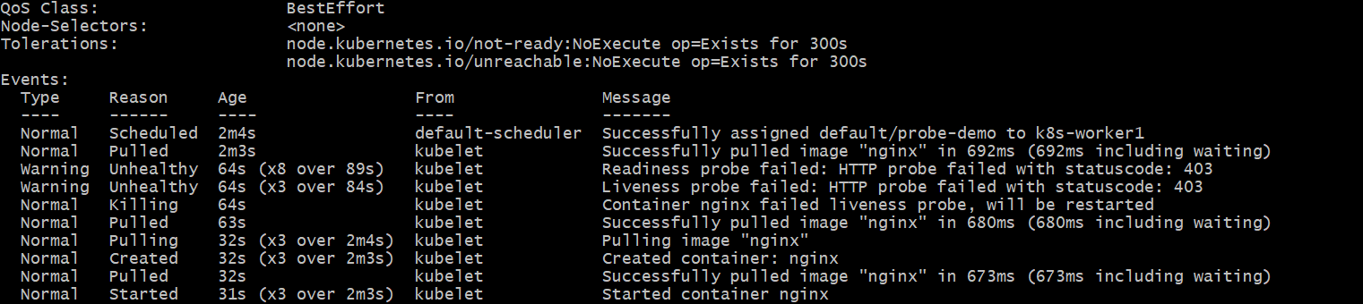
  - kubectl get pod probe-demo -w
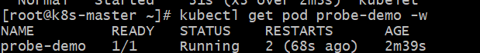
  - Cleanup
kubectl delete pod probe-demo
